1-Markup Languages

📘 What is a Markup Language?
# Source: AI Source: Provided by: [Data Path: Persons Table -> ID Column: 1, Name_En Column: Motasem Essam] -> From: [Chatgpt (GPT‑5 Mini)] on [1/26/2026]
A markup language is a computer language used to annotate text or data in a way that a machine can process and understand it — but doesn't display those annotations directly to the user.

🔹 Key Concept:
# Source: AI Source: Provided by: [Data Path: Persons Table -> ID Column: 1, Name_En Column: Motasem Essam] -> From: [Chatgpt (GPT‑5 Mini)] on [1/26/2026]
A markup language adds structure and meaning to plain text.
It tells software how to display or interpret the text or data — for example:
- "This is a heading"
- "This is a paragraph"
- "This is a link to another document"

📄 Simple Example (HTML):
# Source: AI Source: Provided by: [Data Path: Persons Table -> ID Column: 1, Name_En Column: Motasem Essam] -> From: [Chatgpt (GPT‑5 Mini)] on [1/26/2026]
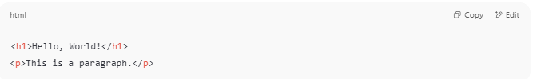
<h1>Hello, World!</h1>
<p>This is a paragraph.</p>

- <h1> is a markup tag that means "heading 1"
- <p> is a tag for "paragraph"
You're not changing the content, but describing what it is and how to render it.

🧩 Examples of Markup Languages
# Source: AI Source: Provided by: [Data Path: Persons Table -> ID Column: 1, Name_En Column: Motasem Essam] -> From: [Chatgpt (GPT‑5 Mini)] on [1/26/2026]
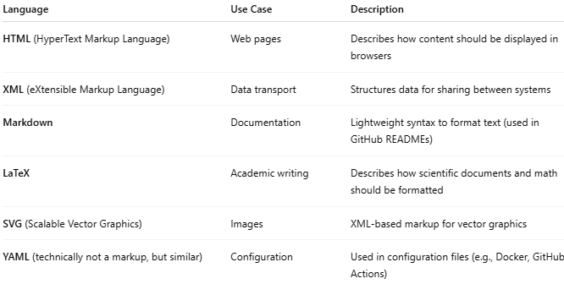
Language | Use Case | Description
HTML (HyperText Markup Language) | Web pages | Describes how content should be displayed in browsers
XML (eXtensible Markup Language) | Data transport | Structures data for sharing between systems
Markdown | Documentation | Lightweight syntax to format text (used in GitHub READMEs)
LaTeX | Academic writing | Describes how scientific documents and math should be formatted
SVG (Scalable Vector Graphics) | Images | XML-based markup for vector graphics
YAML (technically not a markup, but similar) | Configuration | Used in configuration files (e.g., Docker, GitHub Actions)

🔸 Types of Markup:
# Source: AI Source: Provided by: [Data Path: Persons Table -> ID Column: 1, Name_En Column: Motasem Essam] -> From: [Chatgpt (GPT‑5 Mini)] on [1/26/2026]
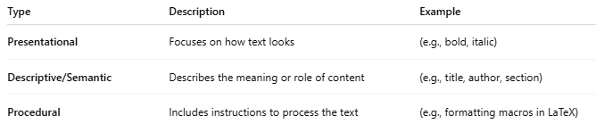
Type | Description | Example
Presentational | Focuses on how text looks | (e.g., bold, italic)
Descriptive/Semantic | Describes the meaning or role of content | (e.g., title, author, section)
Procedural | Includes instructions to process the text | (e.g., formatting macros in LaTeX)

✅ Why Markup Languages Matter:
# Source: AI Source: Provided by: [Data Path: Persons Table -> ID Column: 1, Name_En Column: Motasem Essam] -> From: [Chatgpt (GPT‑5 Mini)] on [1/26/2026]
- Separation of content and presentation
- Machine-readable data
- Universal formats for sharing data across platforms
- Used in web, documentation, data exchange, publishing, and more

